**Password for 26**

**Creating script in /tmp folder**

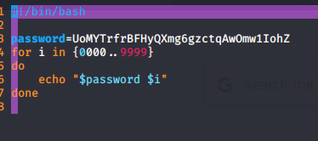

chmod +x script.sh



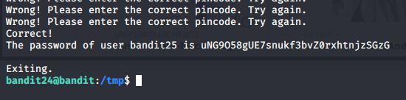



**Password for bandit26**

It is private key that is used for login

We will copy it in our system and login for bandit26 with it

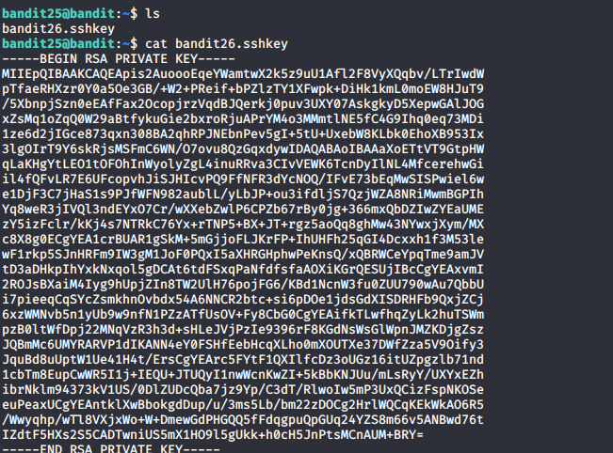

And make it executable file and name it id_rsa like so that it get validated in bandit26

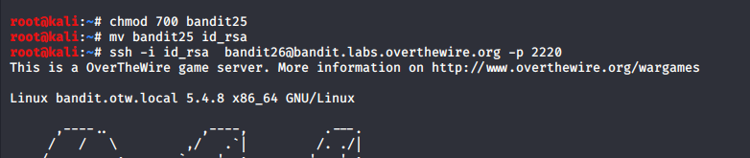

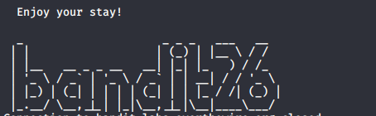

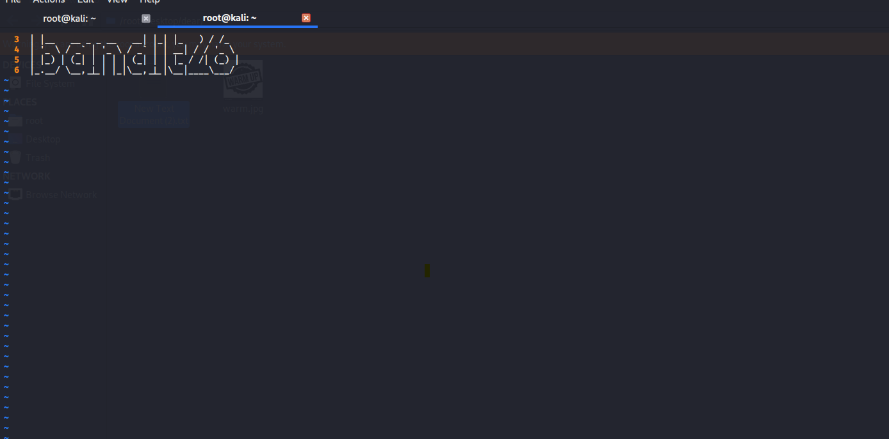

:e /etc/bandit_pass/bandit26 and press enter

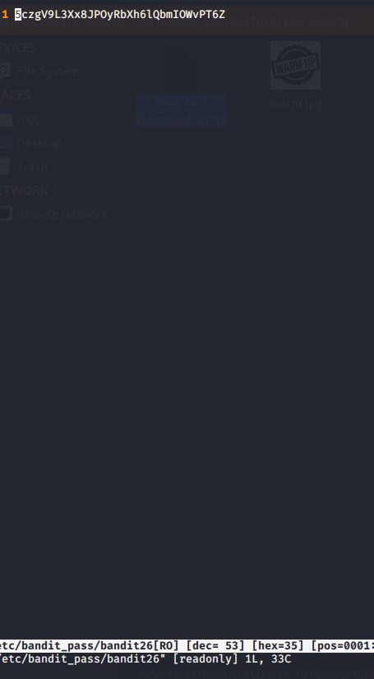

:set shell=/bin/bash

:shell

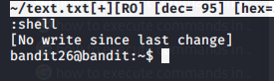

**Password for bandit27**

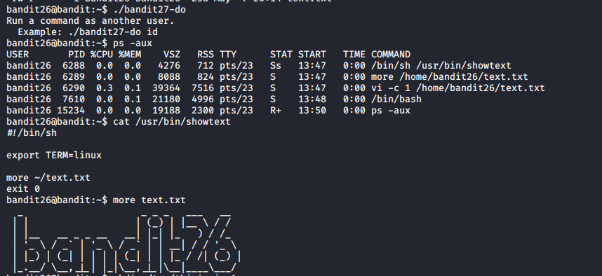

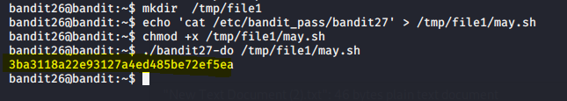

**Password for bandit 28**

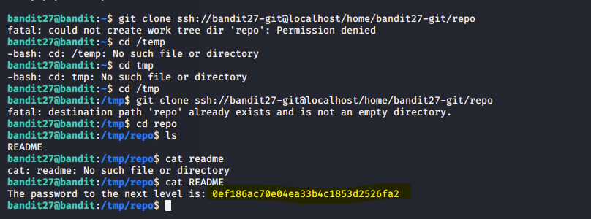

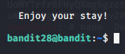

**Password for 29**

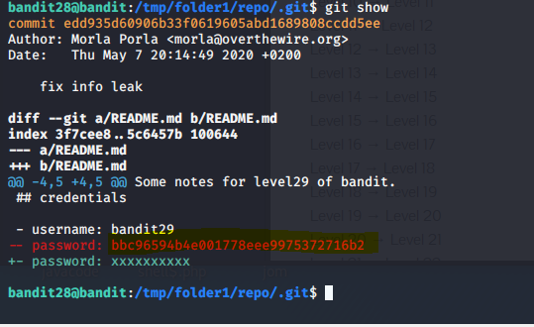

**Password for 30**

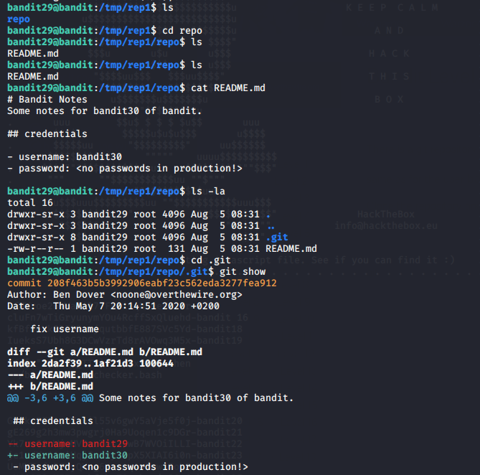

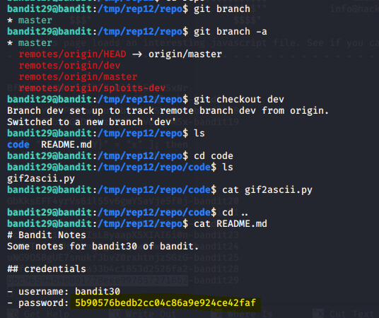



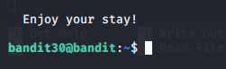

**Password for 31**

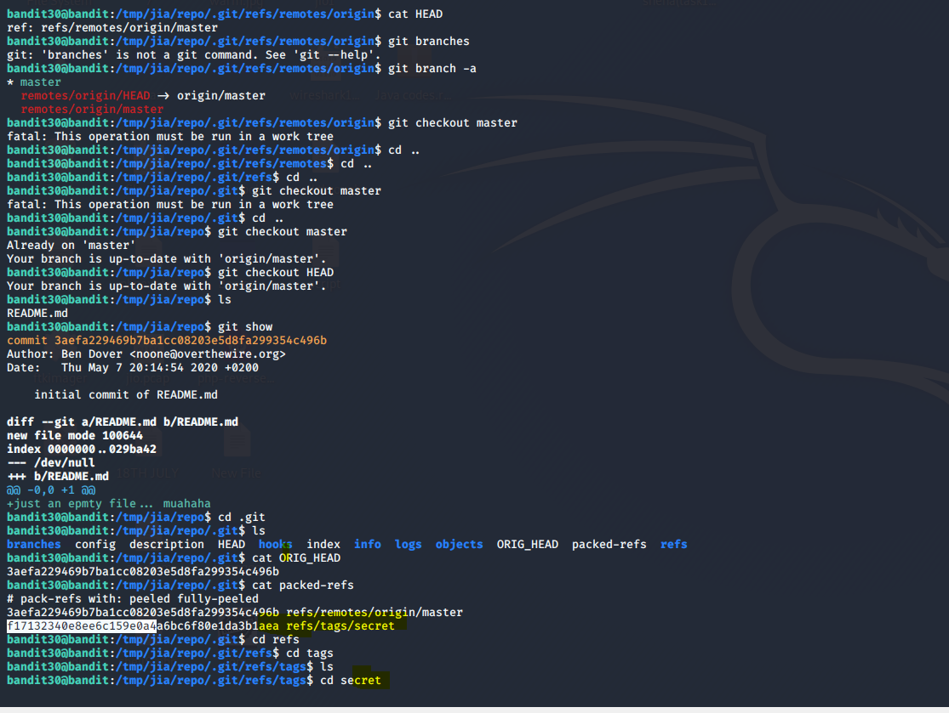

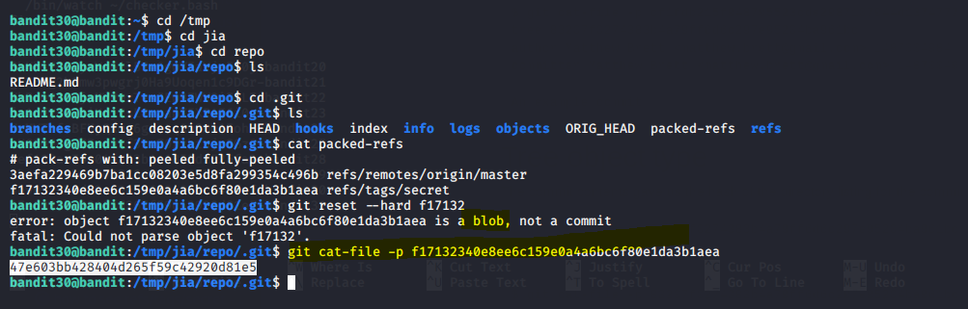

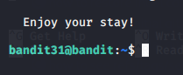

**Password for 32**

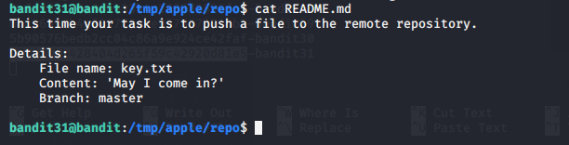

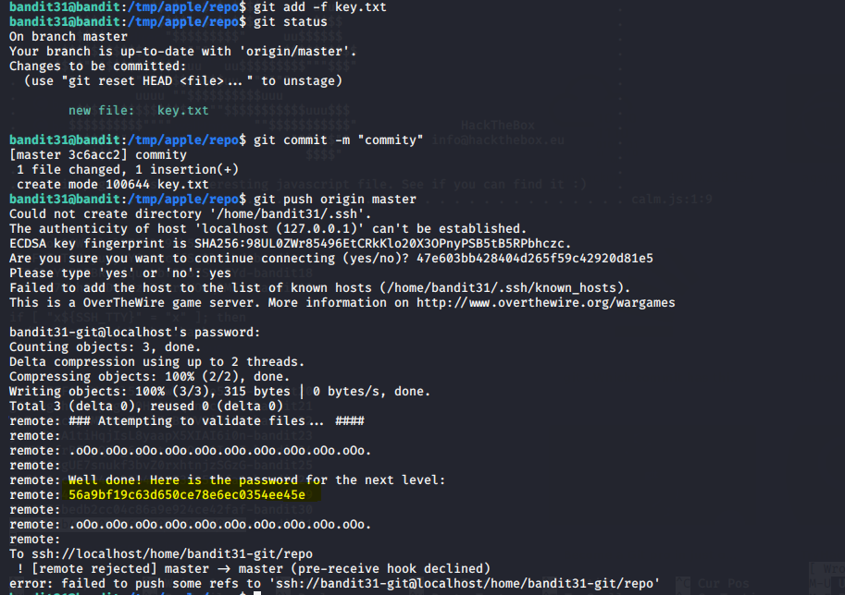

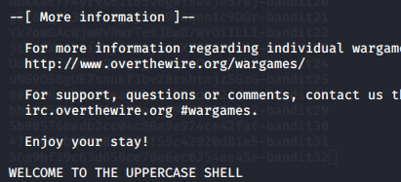

**Password for 33**

